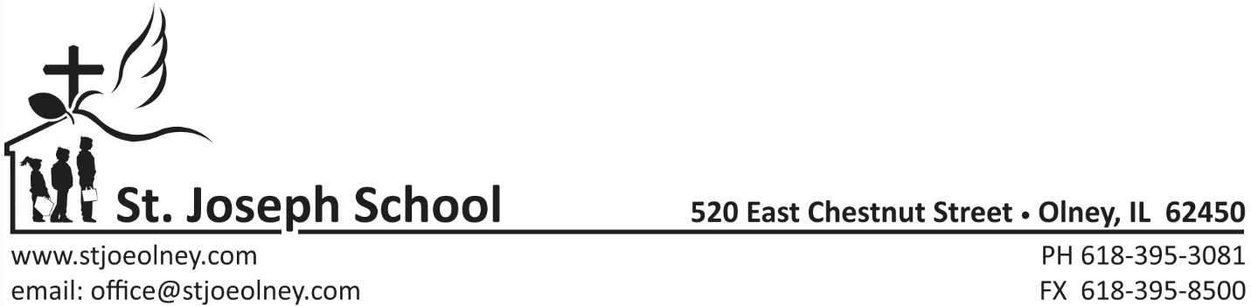

AUTHORIZATION AGREEMENT FOR PREAUTHORIZED PAYMENTS

ST. JOSEPH SCHOOL TAX ID NUMBER 37-0682992

I hereby authorize St. Joseph School, hereinafter called COMPANY, to initiate debit entries to my
[ ] Checking Account [ ] Savings Account (select one) indicated below and the Financial Institution named below to debit same to such account.

FINANCIAL INSTITUTION _____________________________________________

CITY ______________________ STATE ______________ ZIP ________________

TRANSIT/ABA # ___________________ ACCOUNT # _____________________

This authority is to remain in full force and effect until COMPANY AND Financial Institution have received written notification from me of its termination in such time and in such inner as to afford COMPANY and Financial Institution reasonable opportunity to act on it.

NAME _____________________________ SIGNATURE ___________________________

DATE _____________________________

10 Monthly Payments beginning August through May

AMOUNT TO BE DEBITED ___________________________

DATE OF MONTHLY DEBIT ______25th August-May___________________

***Please attach a VOIDED check or deposit slip.

